Thulani Khoza

HP

[Company address]

Table of Contents

2 Project Profile 2

2.1 Tools 2

3 Benefits of the Proposed system 2

4 Function Specification 2

4.1 Administrator 2

4.2 Client 2

4.3 Employee 3

5 Hardware &Software Requirements 3

5.1 Hardware Specification 3

5.2 Software Specification 3

6 System Analysis 3

6.1 Problem Statement 3

6.1.1 Who does the problem effect? 3

6.1.2 What are the boundaries of the problem? 3

6.1.3 When does the Issue Occur? 3

6.1.4 Where is the issue occurring? 3

6.1.5 Why is it important that this problem must be fix? 3

# Project Profile

|  |  |  |
| --- | --- | --- |
| Index | Key | Content |
| 1. | Project Tittle | Acrux Courier Management Information System (ACMIS) |
| 2. | Team Member | Mr T.N Khoza (25662600) |
|  |  |  |

## Tools

|  |  |  |
| --- | --- | --- |
| Index | Key | Content |
| 1. | Front-End Tool | PHP |
| 2. | Back-End Tool | MYSQL |
| 3. | Other Tools | JavaScript & HTML |

# Benefits of the Proposed system

1. Courier Sending
2. Courier Tracking
3. View Courier Total Revenue
4. View & Manage employees

# Function Specification

The allegedly information system comprises three type of users, namely:

1. Administrator
2. Client
3. Employee

Please note that for security measures as well as restricting privileges, the aforementioned system users are required to register in order have full access to the system according to their classifications.

## Administrator

1. The administrator has access to view tracking information which consist of the courier bookings, time it was booked, particulars of a sender and a receiver, time of courier arrival, as well as the destination of where the courier is sent.
2. View the total revenue of courier bookings.
3. Manage employees (i.e. View and remove employee).

## Client

A registered client has access to the following:

1. Make booking for a desired package to be delivered by providing required particulars of both the package sender and a receiver. Once the booking is successful, a notification emerges on the interface with the details to be used for package tracking purposes.
2. As mentioned above, clients can track their packages if they are deliver of not. To track a courier, a client needs to be in possession of the package ID as well as the sender’s name.

## Employee

An employee has access the following:

1. View courier bookings made by clients.
2. Change status of a courier whether it is “Loaded”, “Transit” or “Delivered”.

# Hardware &Software Requirements

## Hardware Specification

|  |  |
| --- | --- |
| RAM | 4GB |
| Hard Disk | MINIMUN OF 50 GB |
| Processor | 2.0 GHZ |
|  |  |

## Software Specification

|  |  |
| --- | --- |
| Operating System | Windows |
| Web Sever | PHPmyAdmin |
| Web Browser | Any is applicable |

# System Analysis

## Problem Statement

Please not that this information system serves to solve problems encountered by customers through the entire delivery process.

### Who does the problem effect?

The delivery company fails to deliver nor fetch packages according to the booking made by customers as required. This affects both the company as well as customers.

### What are the boundaries of the problem?

There’s poor means of communication between the employees (drivers) as well as customers. Deliveries may be delay due to incorrect address that customers provided while booking couriers.

### When does the Issue Occur?

The issue occurs when deliveries are supposed to be made.

### Where is the issue occurring?

The issue occurs where packages to be fetched or delivered are located.

### Why is it important that this problem must be fix?

Customers are not happy with the services provided by the delivery company, as the delivering of their packages is often delayed. Which leads to their packages being damaged or stolen since they have no enough long-term storage.

# Summary of a proposed system solution

The proposed system serves to help both drivers as well as customers to communicate the bookings made, as well as tracking deliveries to ensure that they fetched and delivered in time. In terms of communicating the bookings, during the booking session, the proposed system will request the correct details of when and where deliveries must be delivered. The system will request the following information to the customers:

1. Name of the sender.
2. Destination where packages must be delivered.
3. The address of the sender.
4. The time a booking was made.
5. Name of the package receiver.
6. The address of the package receiver.
7. The date a delivery must be made.

Once the customer has submitted the booking with the aforementioned, a notification with the details to be used in order to track the recently booked courier will be displayed on the user interface. To track the delivery, a customer’s interface is provided where they can track their deliveries by providing a courier ID and a sender’s name.

# Critical success factors for the proposed system

The common critical success factor (s) is to communicate the system requirements well so that the system provides required functions. More of critical success factors are mentioned above (Hardware and software Specification).

# Flow Chart

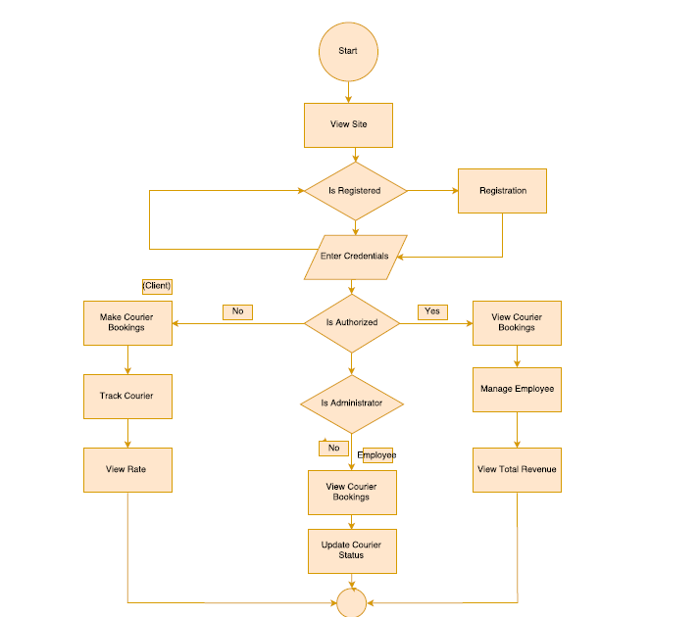

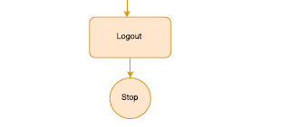

# ERD

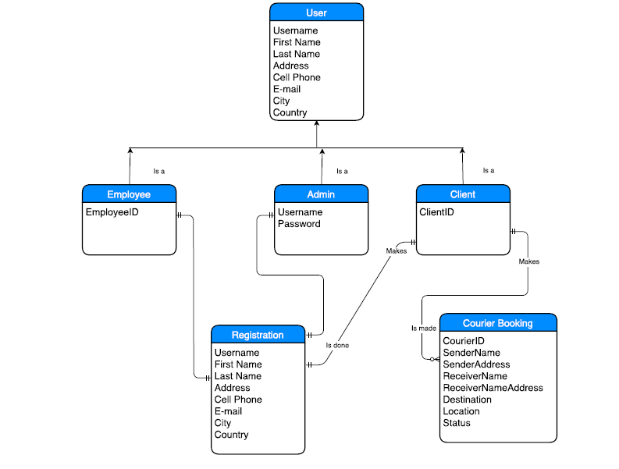

# Use-Case

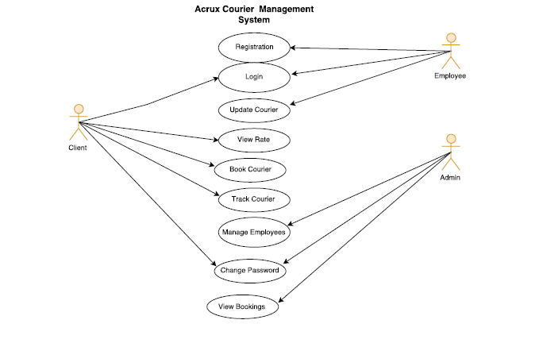

# Prototype



